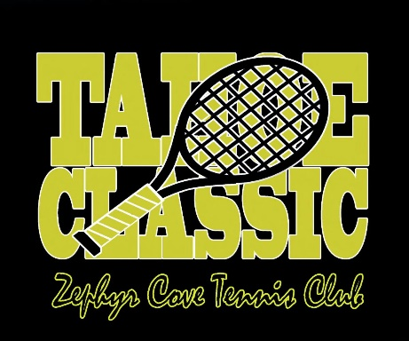
Tahoe Tennis Classic
August 3-6, 2023

DONATION FORM
Please submit donation by July 13, 2023

ITEM DONATION
Description of item(s) donated (color, size quantity, location, number of people, etc.):

Value: Expiration dates (if applicable):
Availability dates (if applicable):
Limitations and/or restrictions:
Contact name for redemption:
Contact Phone: Contact Email:
For more information on donations please call Carolyn Wright at (775)450-1433 or email mailto:mzctennis@gmail.com
MONETARY DONATION - UNDERWRITER
Check number, payable to ZCTC Foundation: Amount:
Credit card number: Expiration date:
Name on credit card: Amount:
Credit card authorization signature:
For more information on monetary donations please call Carolyn Wright at (775)450-1433 or email carolyn@zctennis.com
DONOR INFORMATION
Name(s) as you would like to be recognized in the website/program:
Website:
Mailing address:
City: ZIP:
Phone: Email:

Please return this form along with donation to: ZCTC Foundation
P.O. Box 10215
Zephyr Cove, NV 89448

Zephyr Cove Tennis Club Foundation is a 501(c)(3) non-profit organization. Tax ID Number 46-4951171

OFFICE USE ONLY
Donation number Solicitor
Certificate received Item received

